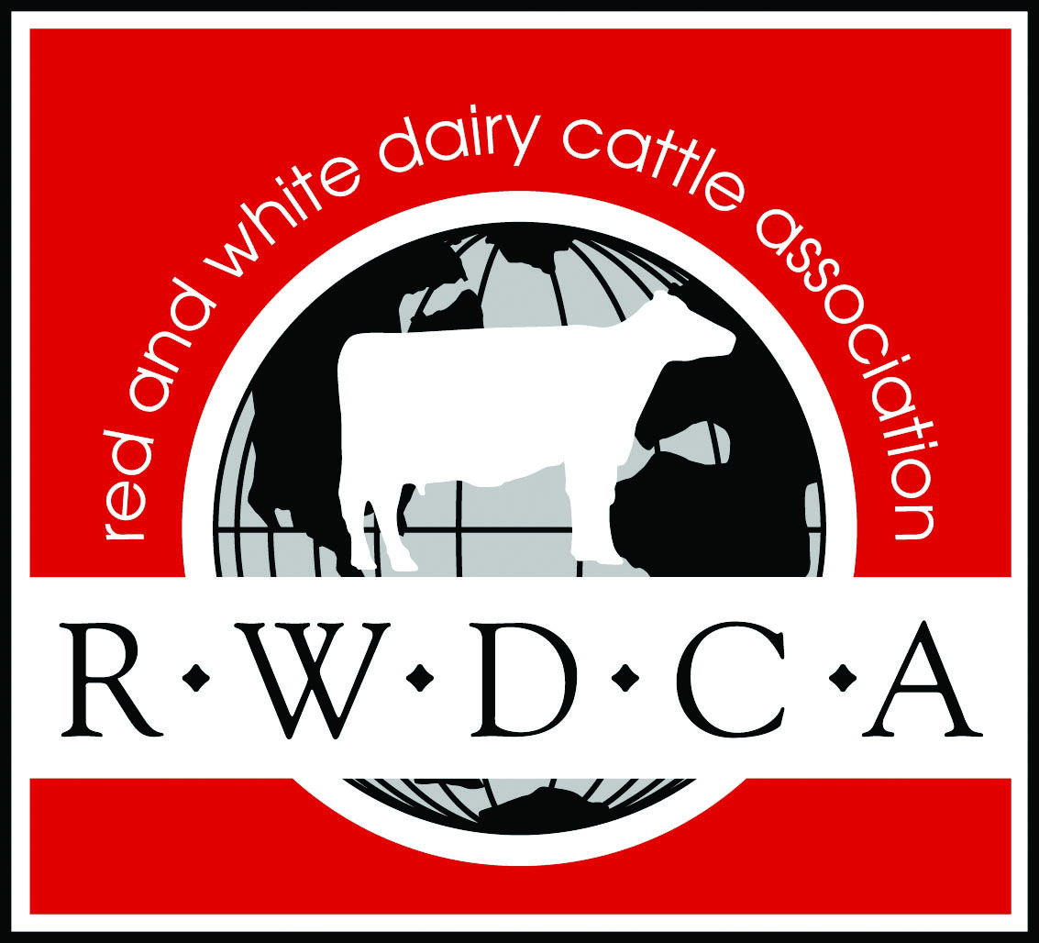 National Red & White Dairy Cattle Association Lease Program
Objectives:
1. To provide the opportunity for both non-farm youth and youth from farms with other breeds to work with Red & Whites
2. To increase participation in RWDCA’s Junior Programs
Guidelines:
1. The recorded owner must be a member of the RWDCA
2. The youth (lessee) must be a junior member of the RWDCA
3. The owner and lessee should be clear on the responsibilities regarding the leased animal
4. The lessee shall file a completed lease agreement and registration paper and a $15 filing fee to the RWDCA (Lifetime Lease $45)
5. The lease agreement must be postmarked by JULY 1 of the program year (With the exception of animals leased to a junior at the RWDCA National Convention).
6. Once the lease is approved, a signed copy and the registration paper will be mailed to the lessee.
7. The owner will still be listed as the owner and the leasing information will be included on this form.
Terms:
1. The program year will coincide with the calendar year
2. The lessee must follow the Junior Show Rules
3. Entries must be shown by the lessee in all cases except by prior written approval. A written statement must be hand delivered to the show chairman by 5:00 p.m. the day before the show for approval. Included in statement –Name, Age and signature of lessee. Cell phone number of a contact person. Class of animal. Name and age of alternate leadsperson. Reason lessee needs an alternate. If approved, the alternate must be the same age or younger of the lessee. Alternate must also be a RWDCA junior member. Adults are not allowed to show in any case. If more than one animal owned by the same junior is eligible for the championship class, an other eligible junior may show the other animal or animals.
4. To lease a cow, the animal must have been leased by the junior as a calf or heifer.
5. Leased animals will qualify for the Junior All-American contest
6. The lease may be renewed for additional program years by filing a new lease agreement and the $15 filing fee with the RWDCA or can be done as a lifetime lease agreement for $45.
7. The lease will automatically terminate at the end of the program year unless a new lease agreement is filed
8. The lessee is limited to two animals per year

NEED TO SEND WITH APPLICATION- COPY OF REGISTRATION PAPER AND $15.00 Fee.

Lease Agreement:
Youth (Lessee):____________________________________________________________________________________________________________

Date of Birth:________________________________________ Phone Number____________________________________________________

Address:____________________________________________________________________________________________________________________

City:_______________________________________________________________ State:_______________ Zip Code:________________________

Animal Name:______________________________________________________________________________________________________________

Registration Number:______________________________________________________________

Recorded Owner:___________________________________________________________________ Phone Number __________________________________________

We, the undersigned, have read, understand and comply with the lease program. We agree to hold harmless the RWDCA, its employees, members, and agents from any and all liability regarding this lease, lease program and leased animal.

Signed:
Recorded Owner:______________________________________________________________________Date:______________________________

Lessee:__________________________________________________________________________________Date:_____________________________

Parent/Guardian:______________________________________________________________________Date:_____________________________
Having received the appropriate fees and this fully executed agreement, I do hereby approve and activate this Lease Agreement.

RWDCA_________________________________________________________Date:______________________________
Mail, Fax or Email to: RWDCA, PO Box 579, Watertown, WI 53094; Fax: 608-299-0800 Phone: 608-790-5595; Email: rwdcainfo@gmail.com

